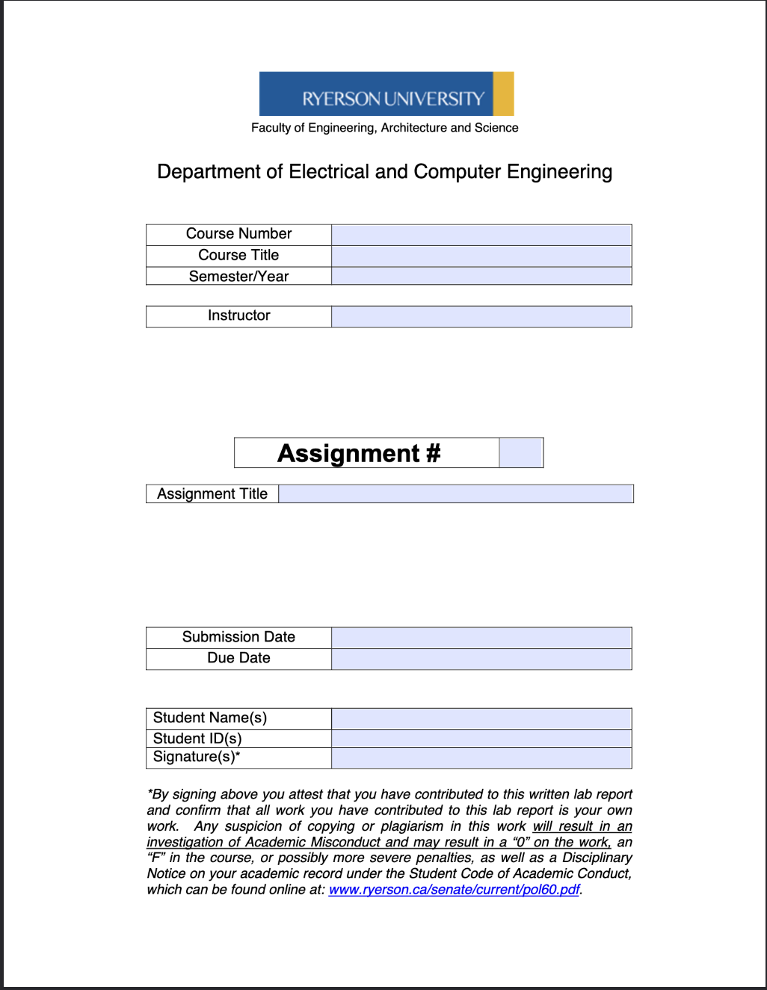
ELE504
Electronic Circuits II
F2024
Dr. Rueda
MP
ELE504 Major Project Pre-Lab 2
October 8th, 2024
October 9th, 2024
Shai Mourad
501170415
SM

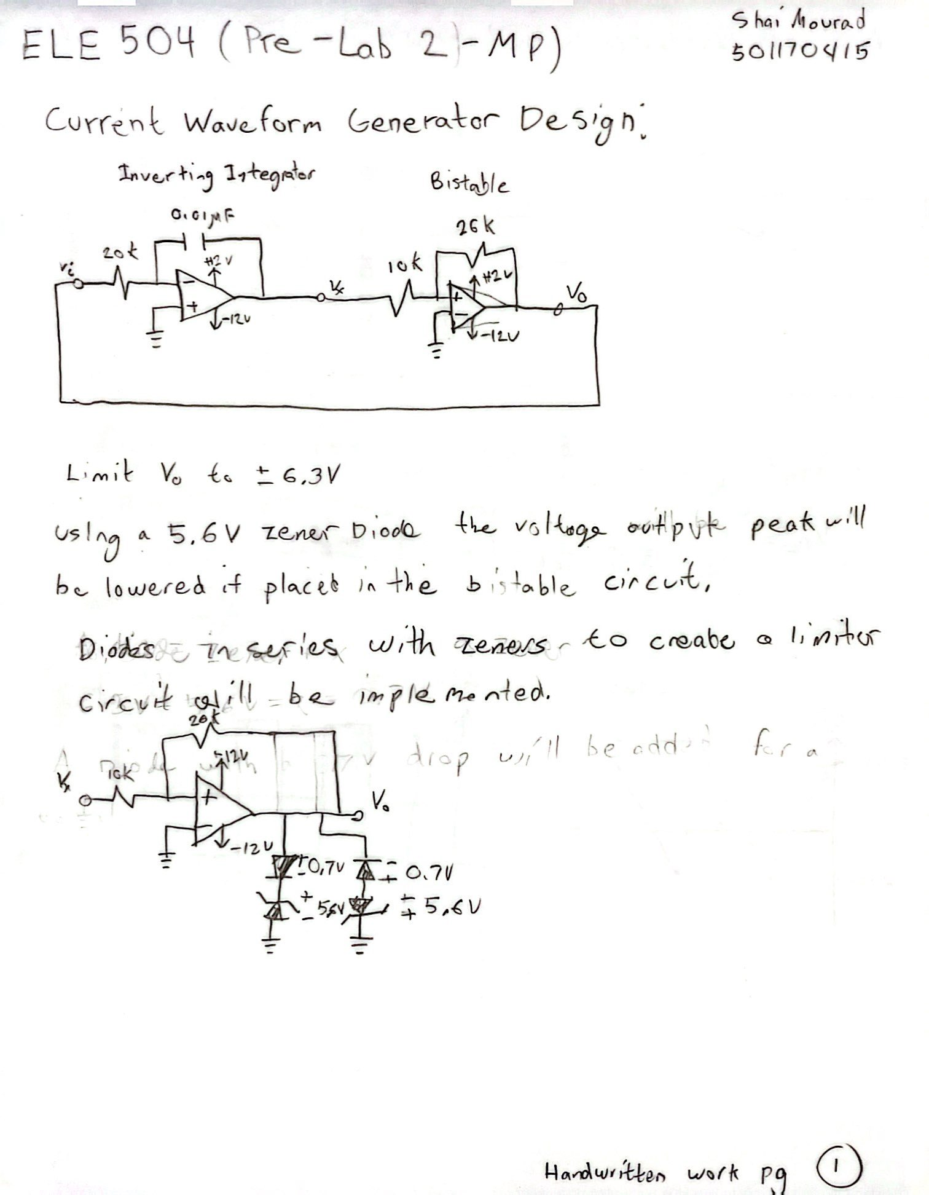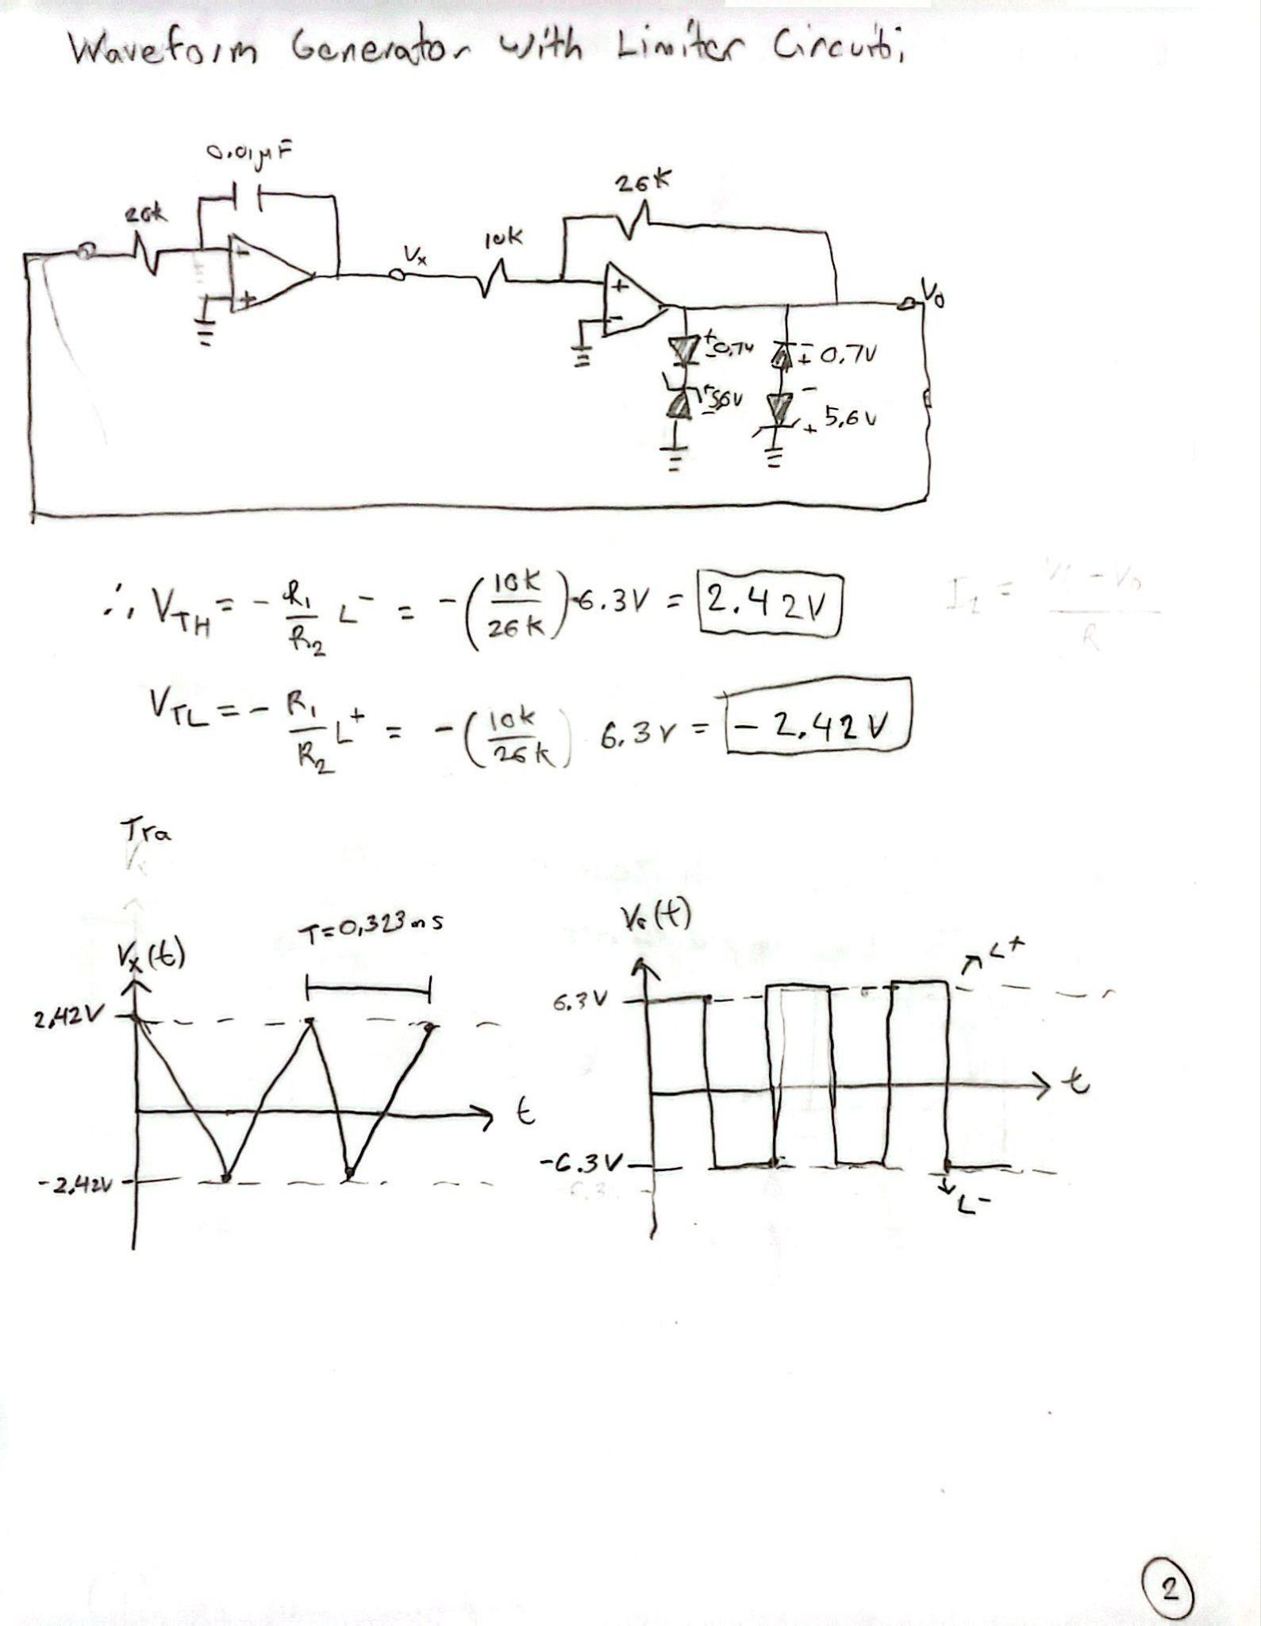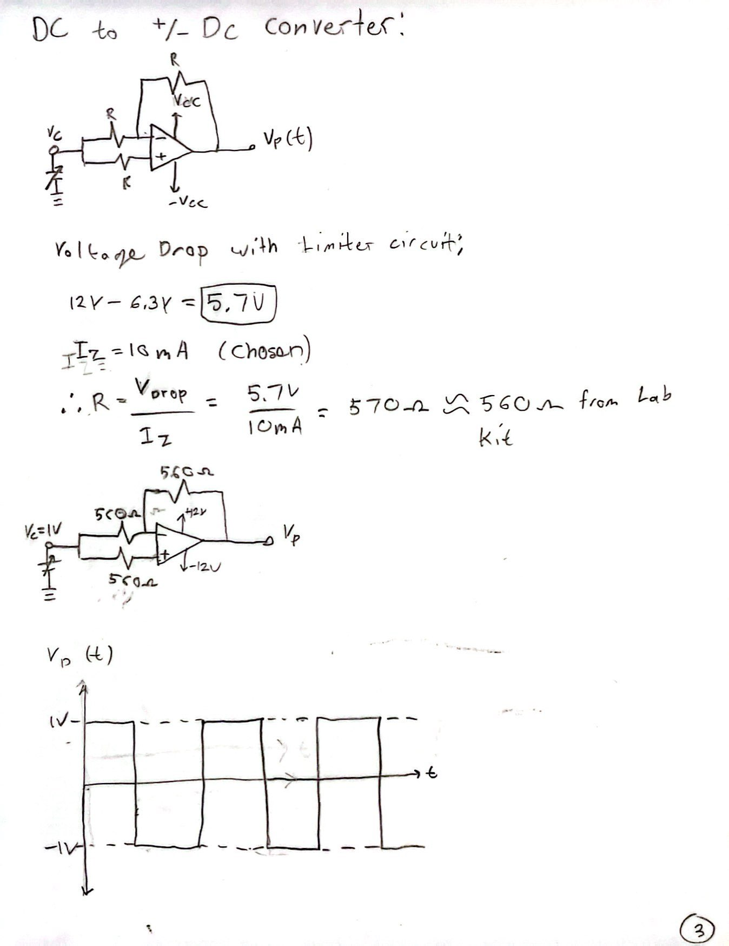

Multisim Section:

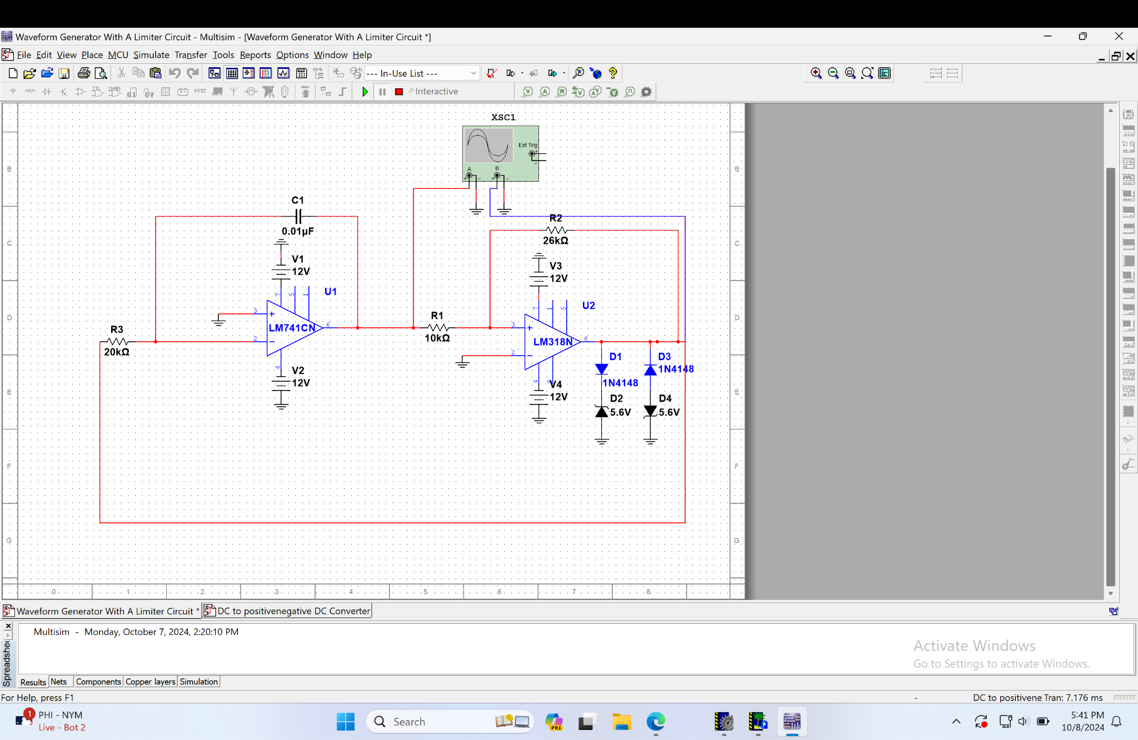
Waveform Generator Design in Multisim With a Limiter Circuit.

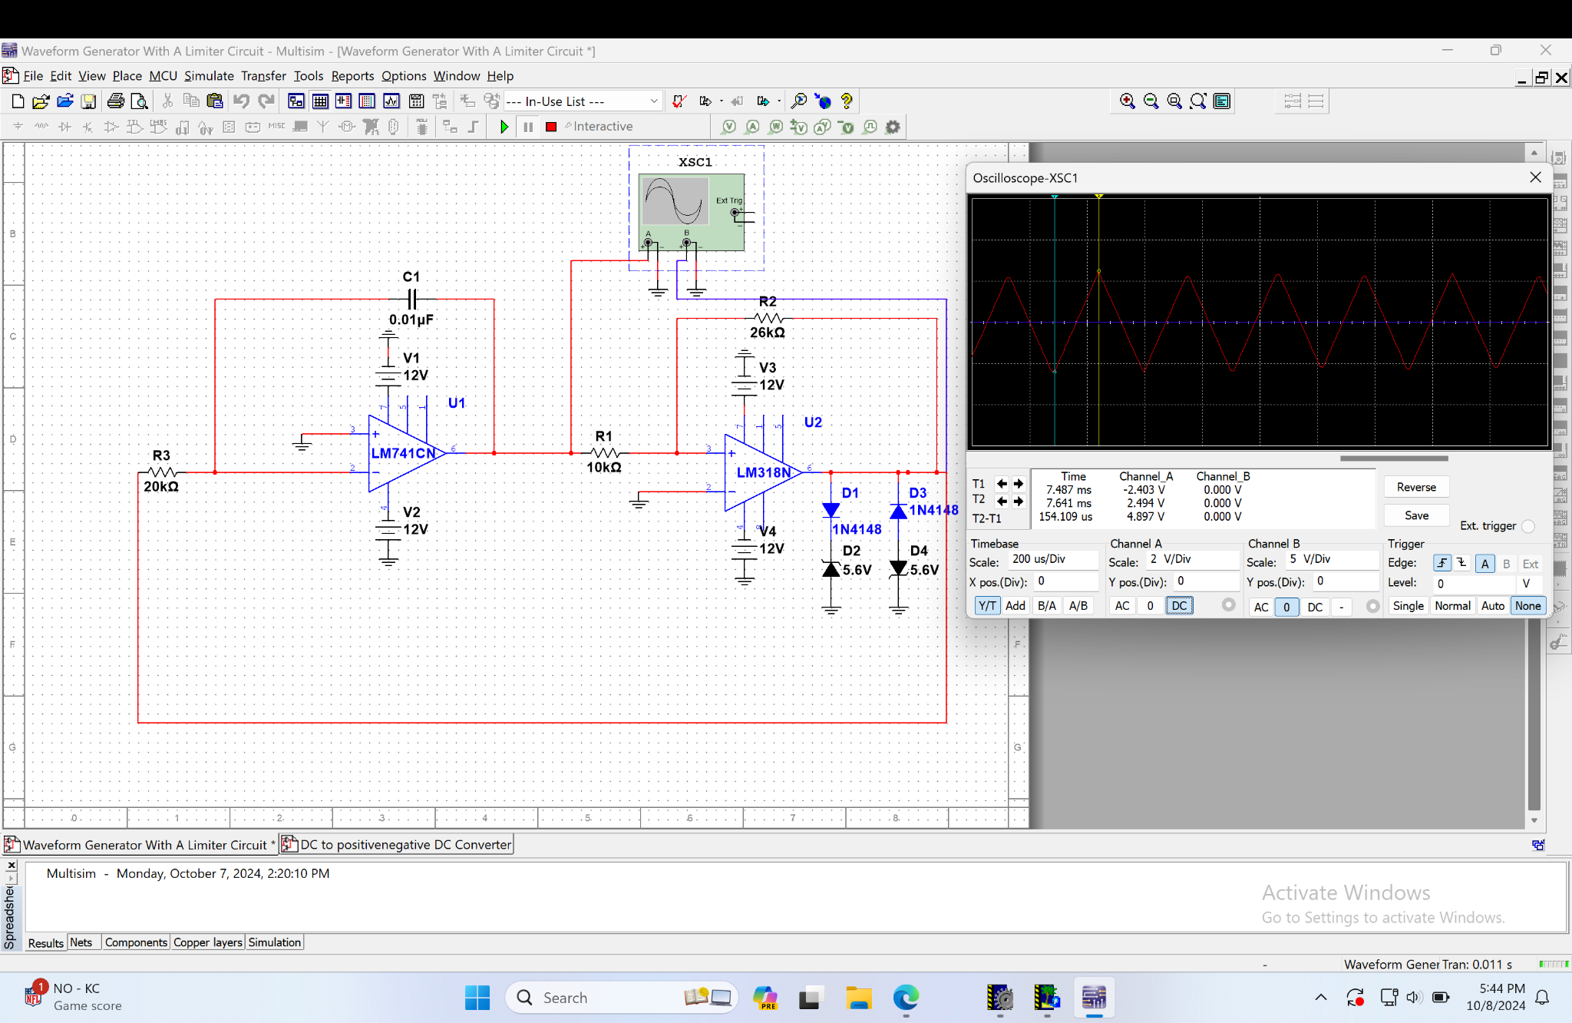
Simulation of the Waveform V_{x}(t) of the Limiter Circuit Design in Multisim

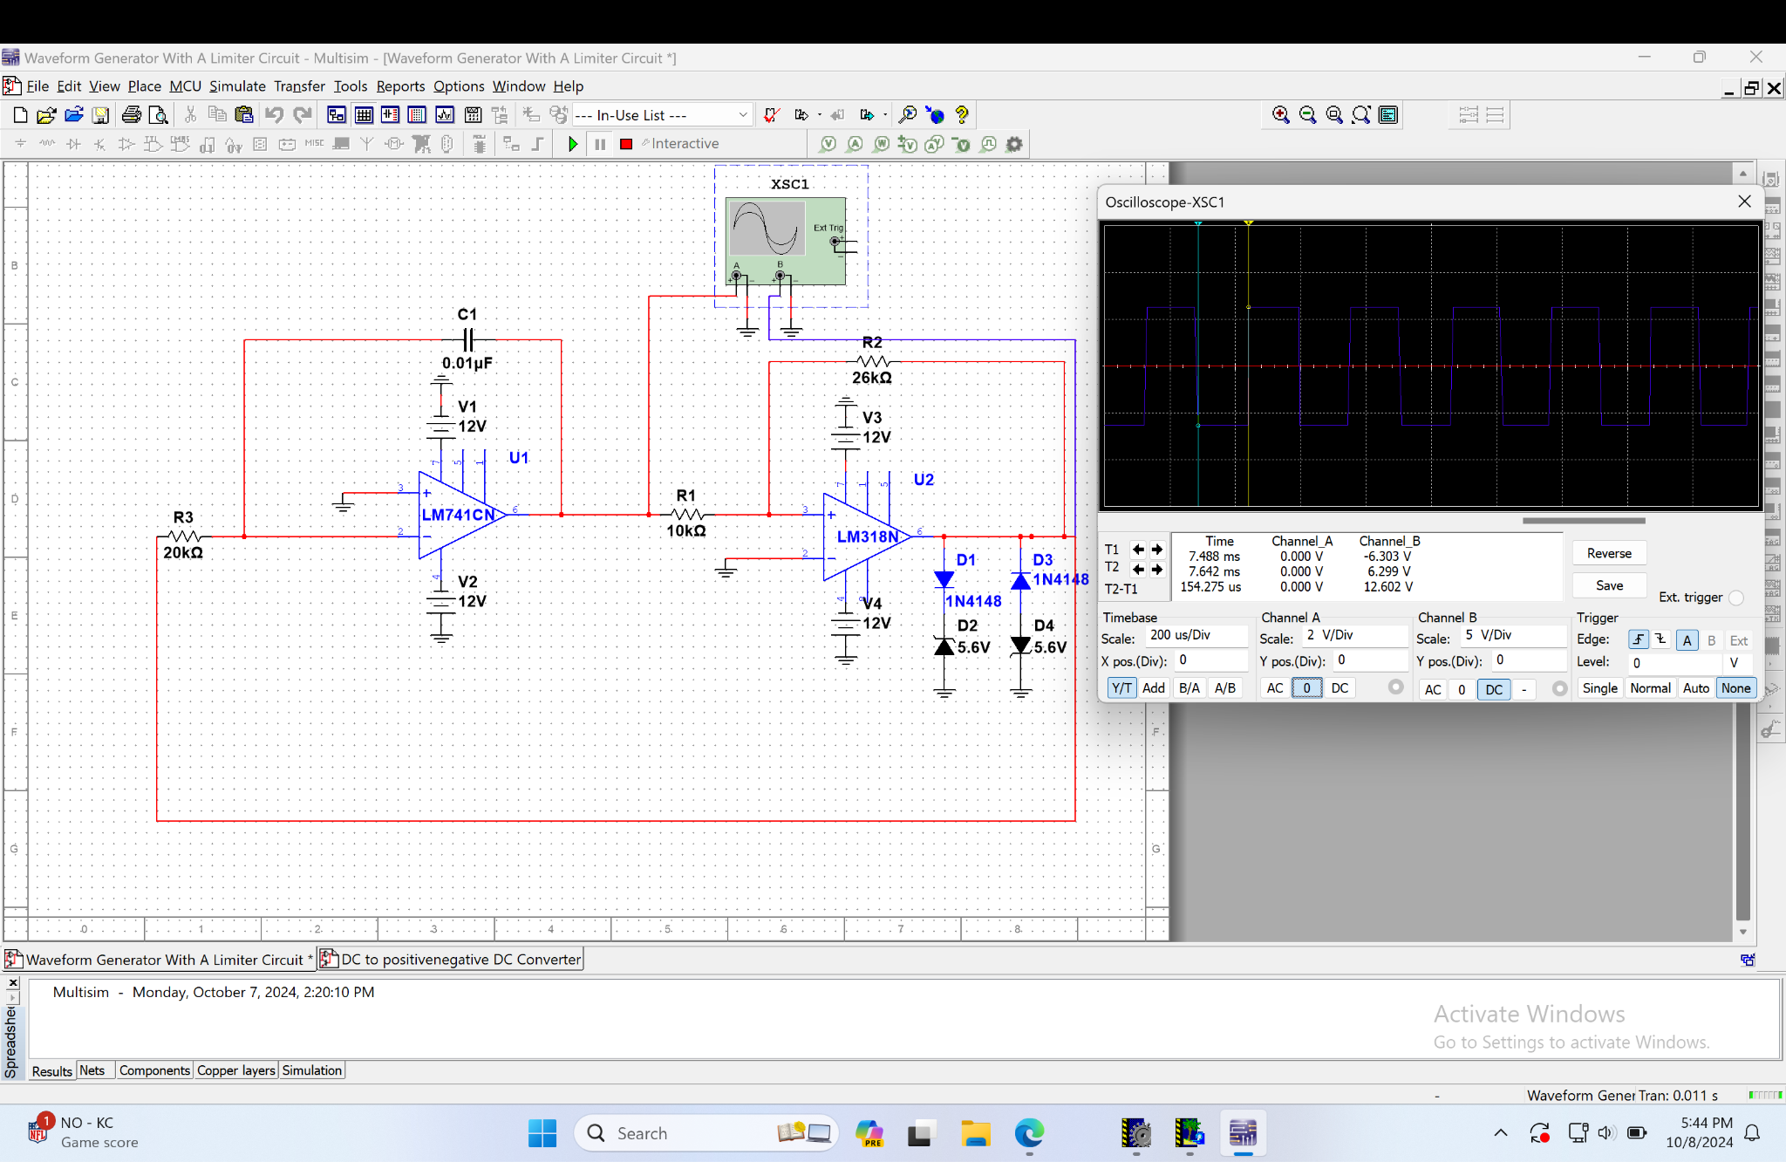
Simulation of the Waveform V_{O}(t) of the Limiter Circuit Design in Multisim

Triangular Waveform (V_{X}) | Pre-Lab | Simulation
V⁺_{p} | 2.42V | 2.494V
V⁻_{p} | -2.42V | -2.403V
T | 0.32 ms | 0.308218ms
f_{x} | 3100Hz | 3244.46Hz
Table 1a. Comparing Pre-Lab and Multisim Simulation Values for V_{X}

Square Waveform (V_{o}) | Pre-Lab | Simulation
V⁺_{p} | 6.3V | 6.299V
V⁻_{p} | -6.3V | -6.303V
T | 0.323ms | 0.30855ms
f_{x} = $\frac{1}{T}$ | 3100Hz | 3240.97Hz
Table 1b. Comparing Pre-Lab and Multisim Simulation Values for V_{O}

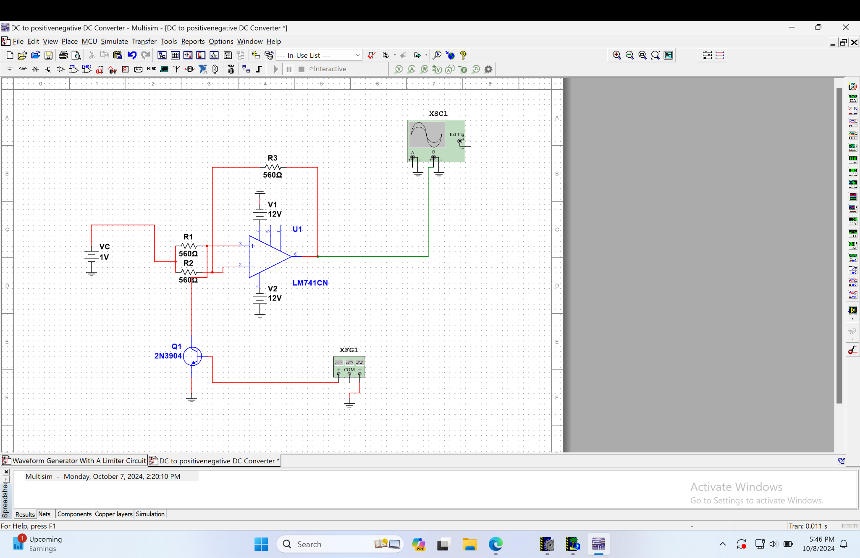
DC-to-+/-DC Converter Design

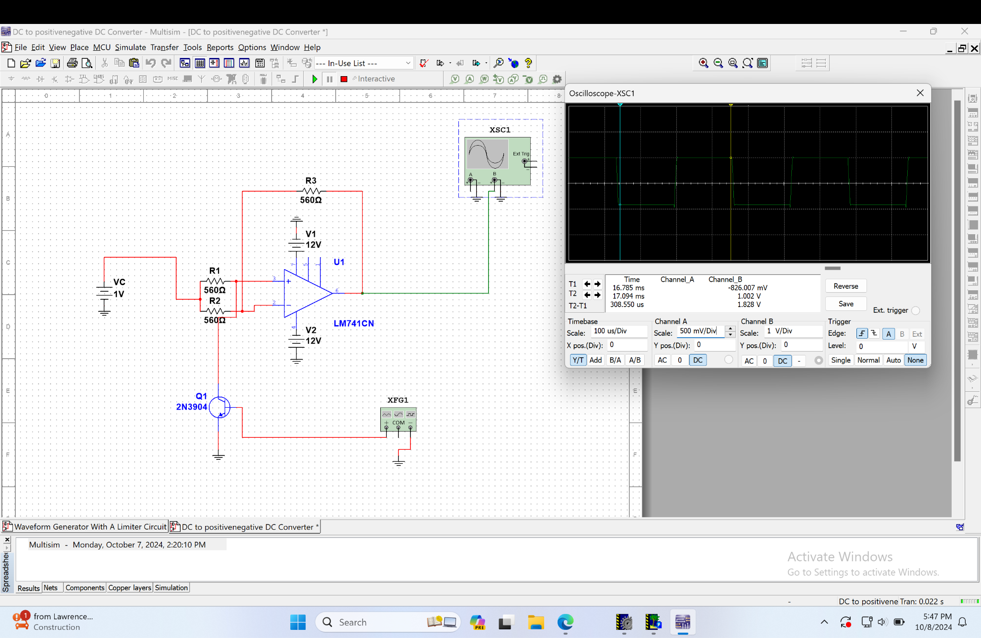
DC-to-+/-DC Converter Design Waveform of V_{P}(t)

Output V_{P}(t) | Pre-Lab | Simulation
V⁺_{p} | 1V | 1.002V
V⁻_{p} | -1V | -0.826V
T | 0.323ms | 0.30855ms
f_{x} = $\frac{1}{T}$ | 3100Hz | 3240.97Hz
Table 2. Comparing Pre-Lab and Multisim Simulation Values for V_{p}

